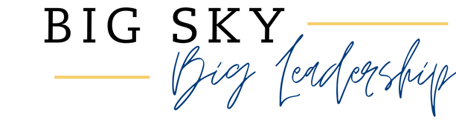


PROGRAM DATES
Learn more about yourself, Wheatland County, and your community and practice skills that you will use every day to make a big difference. Please plan to attend every session.
Dates: November 6^{th,} December 4th, January 8th, February 12th, March 12th, April 9th, and April 30th.
Time: 9 am - 4 pm
Cost: $125; scholarships available

APPLICATION
Name:
Email address:
Phone number:
Mailing address:

Do you need any special accommodations to participate in this program?

What skill do you most hope to learn or develop by participating in Big Sky Big Leadership?

What is a local issue you are passionate about?

What are your favorite snacks?

Please return your application no later than October 1, 2026.

The MSU Extension Service is an ADA/EO/AA/Veteran’s Preference Employer and Provider of Educational Outreach

